Appendix 5: SWIFT Exit Interview Schedule




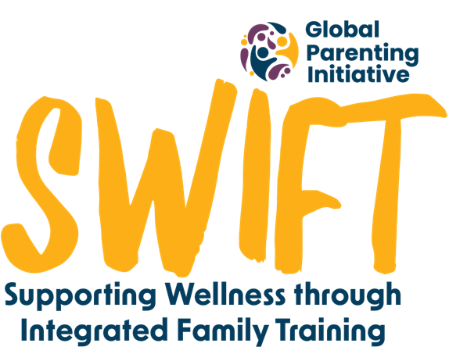


Hi! I just have three quick questions for you about your clinic visit today.

- Are you a parent or a caregiver of a child?

- Did you see a poster in the clinic today advertising a parenting programme?

- Did any of the nurses you saw today tell you about the programme?

Document for interviewers to keep track of and tally responses:

Site________________________ Clinic Name ____________________________
RA ______________________________ Date_______________________
Are you a parent or a caregiver of a child? |  | Did you see a poster in the clinic today advertising a parenting programme? |  | Did any of the nurses you saw today tell you about the programme?
Yes | No | Yes | No | Yes | No

